# 1966 Migrant Worker March

# Cap Times, August 12, 1966

# Waukesha Daily Freeman, August 13, 1966

# Cap Times, August 13, 1966

# Janesville Daily Gazette, August 15, 1966

# Cap Times, August 15, 1966

# Waukesha Daily Freeman, August 16, 1966

# Janesville Daily Gazette, August 17, 1966

# Daily Telegram, August 18, 1966

# Cap Times, August 19, 1966

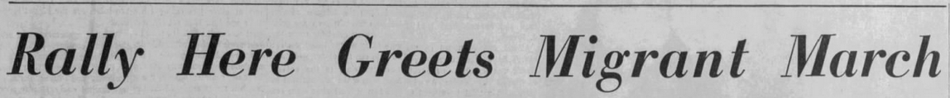

# Daily Telegram, Aug 20, 1966

# Cap Times, August 22, 1966

